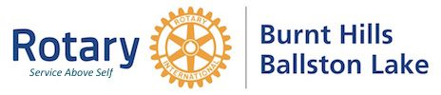
August 2022

Dear Community Member,
The Burnt Hills-Ballston Lake Rotary will be holding their annual golf tournament on October 8 (rain date October 15) at Holland Meadows golf course in Gloversville, NY. We are asking that you help our fundraiser by sponsoring a tee box for $60. Your sponsorship includes a tee box sign, business listing on all printed material and recognition at the awards ceremony.
The money raised by our tournament is used for student scholarships and community projects. Please make checks payable to BH-BL Rotary no later than September 26 and mail to:
Gregg Schorr
818 Salem Drive
Ballston Spa, NY 12020

Thank you in advance for your support and generosity. Please let us know if you have any questions or need further information.

Tournament Committee:
Darlene Bower Mike Brewster Steve Caine Ken Crotty Gregg Schorr

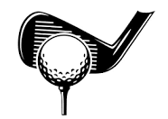

Email: bhblrotary4912@gmail.com – Website: bhblrotary.org

